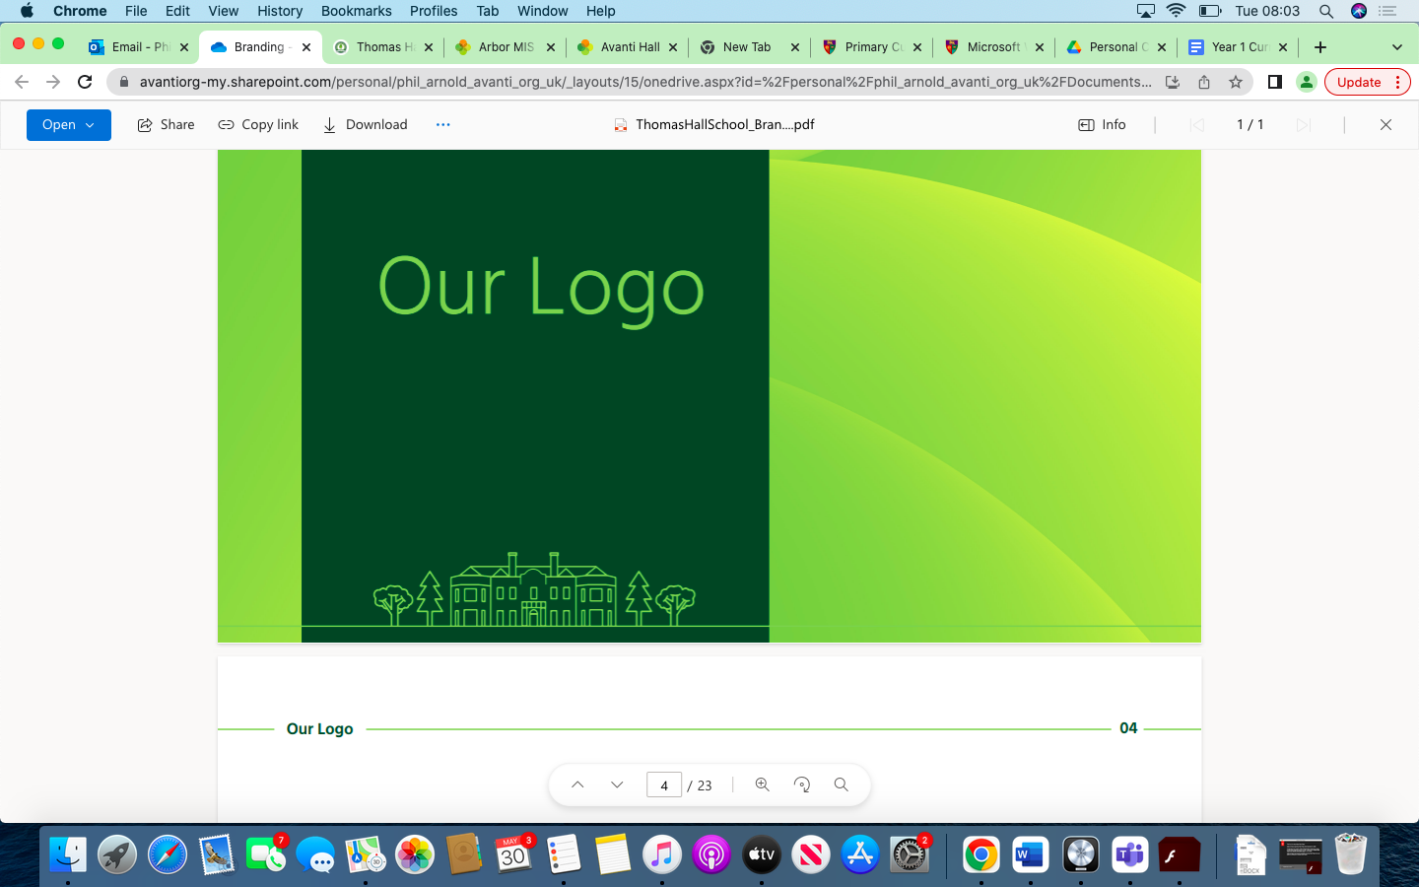

Overview Thomas Hall School 2023-2024

|  |
| --- |
| Early Years and Key Stage 1 |
| Key Stage 2 |
| Key Stage 3 |
| Key Stage 4 |

|  |  |  |  |  |  |  |
| --- | --- | --- | --- | --- | --- | --- |
| **Year** | **Autumn 1** | **Autumn 2** | **Spring 1** | **Spring 2** | **Summer 1** | **Summer 2** |
| **Reception** | Mark making and drawing shapes.  Create collaboratively, sharing ideas, resources and skills. | Mark making and drawing shapes.  Create collaboratively, sharing ideas, resources and skills. | Safely use and explore a variety of materials, tools and techniques, experimenting with colour, design, texture, form and function. | Safely use and explore a variety of materials, tools and techniques, experimenting with colour, design, texture, form and function. | Explore the natural world around them, making observations and drawing pictures of animals and plants. | Explore the natural world around them, making observations and drawing pictures of animals and plants. |
| **Year 1** | **Drawing**  Explore materials and tools for mark making | **Painting**  Explore mark making with paint using primary colours | **Printmaking**  Explore resist and relief block printing, negative stencils and clay printing blocks | **Textiles**  Explore weaving with natural and man-made materials  Work with wax and oil crayon resist on fabric | **3D**  Use natural and man-made materials  Create plaster casts from clay impressions | **Collage**  Explore the visual and tactile qualities of objects  Layer paper to build an image |
| **Year 2** | **Drawing**  Evoke mood and represent movement through mark making | **Painting**  Explore line, colour and shape, make own painting tools and develop colour mixing skills to include secondary colours | **Printmaking**  Create repeated patters with positive and negative space  Print using natural objects as stimulus | **Textiles & Collage**  Explore dip dye technique  Use relief and block printing techniques on fabric  Create work focusing on patten, line, colour using mixed media | **3D**  Take inspiration from the designs of indigenous art  Create 3D sculptures using paper and cardboard | **Creative Response**  Combine drawing and collage to add detail and interest |
| **Year 3** | **Drawing**  Evoke mood and represent movement through mark making | **Painting**  Explore line, colour and shape, make own painting tools and develop colour mixing skills to include secondary colours | **Printmaking**  Create repeated patters with positive and negative space  Print using natural objects as stimulus | **Textiles & Collage**  Explore dip dye technique  Use relief and block printing techniques on fabric  Create work focusing on patten, line, colour using mixed media | **3D**  Take inspiration from the designs of indigenous art  Create 3D sculptures using paper and cardboard | **Creative Response**  Combine drawing and collage to add detail and interest |
| **Year 4** | **Drawing**  Create contour drawings using still life and natural forms as stimulus | **Painting**  Learn about abstract art and develop colour mixing skills to include tertiary colours | **Printmaking & Textiles**  Create monoprint and press prints on fabric and make collages  Create repeated patterns by flipping and rotating images  Use tie dye, knotting and weaving techniques | **3D & Collage**  Create wire structures, focusing on: line and form  Combine 3D materials  Combine a range of techniques such as overlapping and layering | **Painting**  Mix tints and tones to create an ombre effect with paint | **Creative Response**  Combine painting and printmaking techniques |
| **Year 5** | **Drawing & Painting**  Learn about and use the techniques of subtractive drawing  Use organic lines to create landscapes | **Printmaking**  Create three colour prints and combine printing techniques | **Textiles & Collage**  Create wall hangings using layered collage and weaving techniques  Use tie dye, knotting and weaving techniques | **3D**  Create slab and coil pots and learn techniques to joins and seal clay sections  Create tissue paper bowls | **Painting**  Explore a range of effects which can be achieved using watercolour paint | **Creative Response**  Combine printmaking and textiles to embellish fabric |
| **Year 6** | **Drawing**  Combine techniques to create abstract images Learn about surrealism and portraiture | **Painting & Collage**  Create still life compositions by combining different media and in response to cubist work  Adapt and refine ideas and techniques and respond to different styles of artists and art movements | **Printmaking & Textiles**  Use perspective drawings as a starting point for textiles work  Explore batik technique  Draw and paint on fabric surfaces | **3D**  Explore shape, form and colour and explore the effect of heat to create Chihuly-syle ‘glass’  Explore combining techniques to create sculptures using mixed media including recycled materials | **Painting**  Combine techniques to create the illusion of water and depth | **Creative Response**  Combine drawing and batik to add detail |
| **Year 7** | Geometry and Form: Leaves, Patterns, texture.  “The Formal Elements of Art”  “Colour Theory” | Vincent Van Gogh: “A starry Night”. Life and work. Water colour techniques.  Art History and Van Gogh and Post- impressionism | Vincent Van Gogh: “A starry Night”. Life and work. Water colour techniques.  Art History and Van Gogh and Post- impressionism | Printmaking (lino cuts): Create a design with a bee on a seed packets.  Learn about the decline of the bee population and what can be done to encourage its growth. | Product Design: Seed packets. Printmaking techniques, Typography  Cross-curricular link:  Environmental Science projects: The decline of the bee population. | 3D Modelling: The art of studio Gibli and its award winning animations.  Learn to draw and sculpt a manga character of your choice. |
| **Year 8** | FOOD: Sarah Graham (AQA 2015 topic)    Sarah Graham is a contemporary artist, who creates large oil paintings of sweets. Techniques: Colour theory, reflection, perspective composition. | Courtney Mattison and  Yellena James: Coral Illustration  Environmental art projects on the eco system in the sea.  Techniques: fine detail illustration, abstract realization of the natural world, colour theory. | Courtney Mattison and  Yellena James: Coral Illustration  Environmental art projects on the eco system in the sea.  Techniques: fine detail illustration, abstract realization of the natural world, colour theory. | DADA Collages: The Art of Terry Gilliam.  Dada as a response to WW1. Dada artists and their work in context.  Creative collage making, political art, typography, graphic design solutions before photoshop. | David Hockney:  Yorkshire landscapes (water colour)  Life and work of David Hockney. Surrealismn, Pop-art, modern art, cubism, abstract realization of the natural world, colour theory. | David Hockney: Yorkshire landscapes (water colour)  Life and work of David Hockney. Surrealismn, Pop-art, modern art, cubism.   abstract realization of the natural world, colour theory. |
| **Year 9** | Portraiture: learn to draw the human face in detail.  Starting with the eyes, lips, nose and ears separately, before combining them in a whole face.  Pencil drawing technique, ink, skin colour | Portraiture: learn about different portrait artist and their varied approach to the human face. Experiment with different media for different effects: water colour pencils, mixed media, acrylics, collage. | Frida Khalo: learn about her life and work. Learn about the symbolism in her portraits. Learn how to build up a portrait painting in her style.  Experiment with a variety of media. | Introduction to the GCSE curriculum for Art and Design.  Chose a topic for your sketchbook. Create creative mind maps to collect your ideas. Annotation and historical research, | Students who are not taking a creative GCSE, will be given the opportunity to construct a piece of art in response to one of seven past exam paper topics. | Introduce students to a range of appropriate materials, processes and techniques of art, craft and design. Give them guidance as they explore and exper -iment and begin the process of developing knowledge, understanding and skills. |
| **Year 10&11**  **(GCSE Art is a 2 year course)** | Introduction to GCSE Art and Design:  Understand the syllabus. Layout design and creative planning in your sketchbook.  Learning to read past exam papers and work within the 4 assessment objectives | Art History: The Knowledge:  Students experience a range of traditional and/or experimental ways of developing, refining and recording ideas.  • Drawing • painting • sculpture • installation • lens/light-based media • photography and the moving image • printmaking • mixed media • | As pupils progress into KS4, they should be able to think critically and develop a more rigorous understanding of art and design. They should also know how art and design both reflect and shape our history, and contribute to our culture. | An exploration of practical and critical/contextual work through a range of 2D and/or 3D processes and new media technologies. This is a art craft and design course where students can work in appropriate art, craft and design materials and processes dependent on their interest and individual abilities. | Students should produce practical and contextual work associated with one or more area(s) of fine art, such as those listed below: • Drawing • painting • sculpture • installation • lens/light-based media • photography and the moving image • printmaking • mixed media • | Coursework: Portfolio and 2 internally set projects, which students will develop over the course of two years. Students will explore and develop two coherent projects through expanding their artistic mind by making exciting discoveries through creative investigations |
|  |  |  |  |  |  |  |