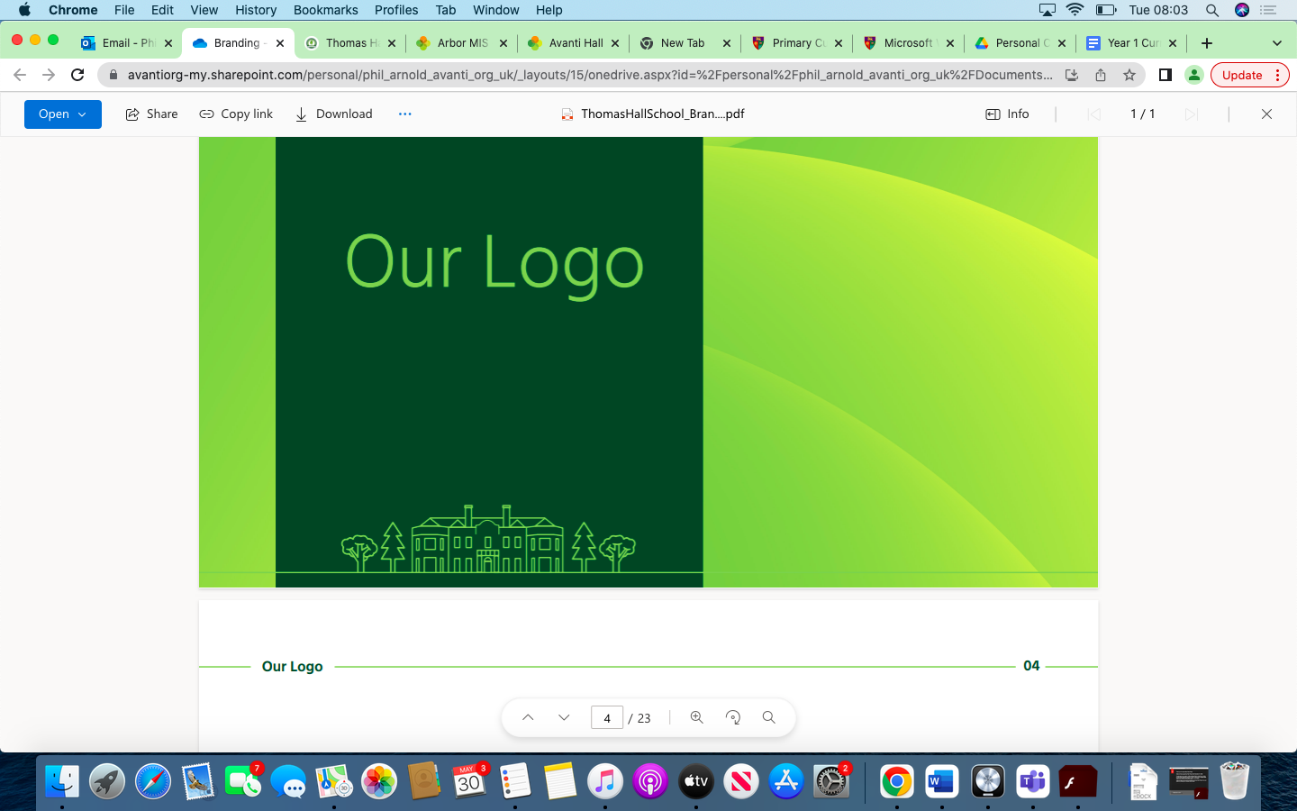

Environmental Science Overview Thomas Hall School 2023-2024

|  |
| --- |
| Early Years and Key Stage 1 |
| Key Stage 2 |
| Key Stage 3 |
| Key Stage 4 |

|  |  |  |  |  |  |  |
| --- | --- | --- | --- | --- | --- | --- |
| **Year** | **Autumn 1** | **Autumn 2** | **Spring 1** | **Spring 2** | **Summer 1** | **Summer 2** |
| **Reception** | Explore the natural world around them.  Describe what they see, hear and feel whilst outside.  Understand the effect of changing seasons on the natural world around them. | Explore the natural world around them.  Describe what they see, hear and feel whilst outside.  Understand the effect of changing seasons on the natural world around them. | Describe their immediate environment using knowledge from observation,  discussion, stories, non-fiction texts and maps.  Explore the natural world around them, making observations and drawing pictures of animals and plants. | Describe their immediate environment using knowledge from observation,  discussion, stories, non-fiction texts and maps.  Explore the natural world around them, making observations and drawing pictures of animals and plants. | Recognise some environments that are different to the one in which they live. | Know some similarities and differences between the natural world around them and contrasting environments, drawing on their experiences and what has been read in class.  Understand some important processes and changes in the natural world around them, including the seasons and changing states of matter. |
| **Year 1** |  |  |  |  |  |  |
| **Year 2** |  |  |  |  |  |  |
| **Year 3** |  |  |  |  |  |  |
| **Year 4** |  |  |  |  |  |  |
| **Year 5** |  |  |  |  |  |  |
| **Year 6** |  |  |  |  |  |  |
| **Year 7** |  |  |  |  |  |  |
| **Year 8** |  |  |  |  |  |  |
| **Year 9** |  |  |  |  |  |  |
| **Year 10** |  |  |  |  |  |  |
| **Year 11** |  |  |  |  |  |  |